Session by Sahil Sharma: A Thesis Supervisor

Thesis – Make a project.

Conferences – Conference on Computer Vision and Pattern Recognition (CVPR), Conference on Neural Information Processing Systems (NIPS), International Conference on Computer Vision (ICVV), International Conference on Multimedia Retireval (ICMR)

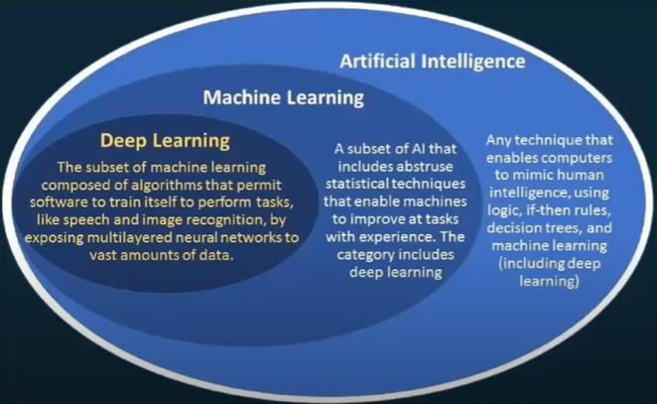

Images – CNN, Text – RNN, GANs, Auto-Encoders, Reinforcement Learning, XAI, transfer learning, LSTM, GPT-3, BERT,

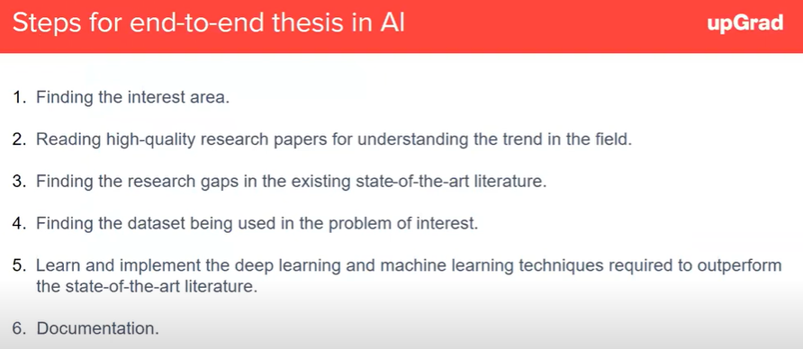

Paperswithcode.com, read good research papers with **impact factor > 1**, it is compulsory to give the dataset name in the thesis for good paper,

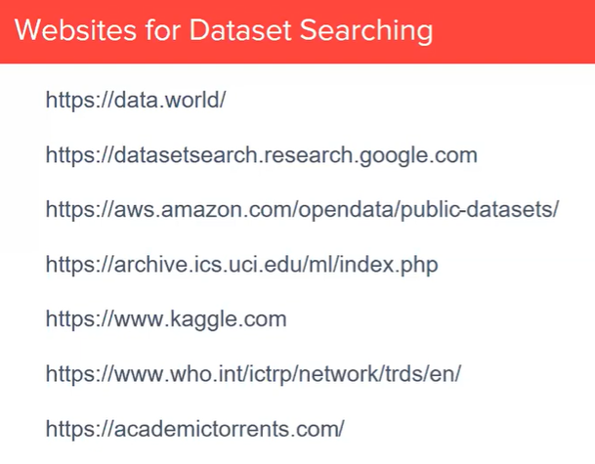

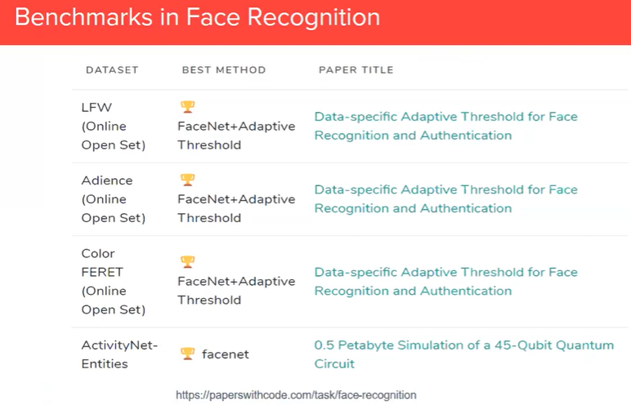

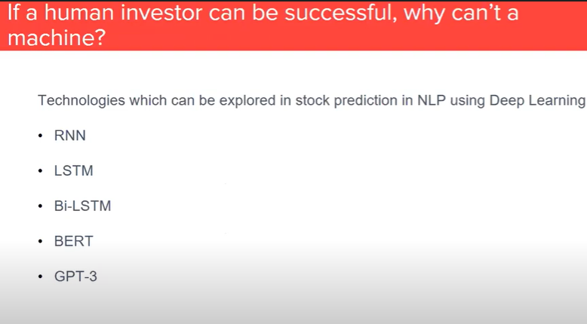

1. Read research papers from the past 20 months
2. Do literature survey of papers

Mendley Guide Videos: <https://www.mendeley.com/guides/desktop>

